

**Information Search and Analysis Skills  
(ISAS)  
  
“React-Native Framework”**

**Name:**

**Kapten Bintang**

**M.Dani Setiawan**

**Class: 3SC5**

**Faculty : M.Idham Khalif S.Kom**

**Continuing Education Program Center for Computing and Information Technology  
Faculty of Engineering  
University of Indonesia**

**2019**

**PREFACE**

Praise God Almighty, for the presence of plenty of mercy and his grace, so that we can complete this Information Search and Analysis Skills (ISAS) with the title “React Native Framework”. Without His mercy, we would not be able to complete this project in time. Even though there are many obstacles that author face on making this project, but finally author can finish this project.

The author also thanked Mr. Idham Khalif as a lecturer who has provided guidance to the author and advice in the process of preparing this ISAS. Not to forget the author thanked the various parties who have provided encouragement and motivation so that the ISAS can be completed on time

Author know that the results of this article is far from perfect and there are still many shortcomings, author hope readers will give comments and suggestions in building this article in order to become better. We hope this article can be useful for those who read or hear, especially for CCIT students of the Faculty of Engineering UI.

Thank you,

Depok,September 2019

Author

**TABLE OF CONTENTS**

PREFACE ii

TABLE OF CONTENTS iii

TABLE OF FIGURE iv

CHAPTER I INTRODUCTION

1. Background 1
2. Writing Objective 2
3. Problem Domain 2
4. Writing Methodology 2
5. Writing Framework 2

CHAPTER II BASIC THEORY

1. Definition of Programming Language 4
2. Definition of JavaScript Language 4
3. Definition of React.js 5
4. Definition of React-Native 5
5. The Different of React and React Native 6

CHAPTER III PROBLEM ANALYSIS

1. How React-Native works 7
2. Implementation of Apps React Native 9
3. The Advantages and Disadvantages of React Native 10

CHAPTER IV CONCLUSION & SUGGESTION

4.1 Conclusion 12  
4.2 Suggestion 12

BIBILIOGRAPHY 13

**TABLE OF FIGURES**

Figure 3.0 React-Native Works 7  
Figure 3.1 Build Process React-Native 8  
Figure 3.2 The Example Code 10

**CHAPTER I  
INTRODUCTION**

1. **Background**

Mobile application development is similar to Web application development and has its roots in more traditional software development. One critical difference, however, is that mobile applications (apps) are often written specifically to take advantage of the unique features a particular mobile device offers.One way to ensure that applications show optimum performance on a given device is to develop the application (app) natively on that device.

JavaScript was created by Brendan Eich in 1995 during his time at Netscape Communications. It was inspired by Java, Scheme and Self.javascript has a rich and fascinating history. It continues to be one of the most hated languages on the planet, often for reasons that have long since faded into irrelevance. JavaScript has become the de-facto standard programming language of the Web, not only because of its first-mover advantage, but because it is open, standardized, and, most importantly a very good language; well-suited to the Web with its dynamic nature and tight integration with the DOM.

React-native was made from the JavaScript language. In 2012 Mark Zuckerberg commented, “The biggest mistake we made as a company was betting too much on HTML5 as opposed to native”. React Native was announced at Facebook’s React.js conference in February 2015 and open-sourced in March 2015.With the rise of React Native popularity and the growing number of popular mobile apps (such as Facebook, Instagram, Pinterest, Uber, Discord, SoundCloud, Skype…)

With React-Native, Developers can develop mobile, web, iOS and UWP applications quickly and safely instead of using normal JavaScript. Today, React-Native is used by many developers around the world. Specifically, in Indonesia, React-Native is one of the top programming languages ​​used by many developers to develop mobile applications

1. **Writing Objective**
2. Definition of Programming Language
3. Definition of JavaScript Programming Language
4. Definition of React.Js
5. Definition of React-Native Framework
6. The Different of React and React-Native
7. **Problem Domain**

Accordance with the title of ISAS "React-Native Framework" We will discuss:

1. How React-Native works
2. The Advantages and Disadvantages of React-Native
3. Implementation of Apps React-Native
4. **Writing Methodology**

**Library Research Method**

Collecting data with browsing information from reference source contain on online sites that relate with the topic of this ISAS.

**Discussion Method**

After collecting data from reference source, we discuss and compose the data into structure contents for completing this ISAS.

1. **Writing Framework**
   * 1. **Chapter I Introduction**

* Background
* Writing Objectives
* Problem Domain
* Methodology
* Writing Framework
  + 1. **Chapter II Basic Theory**
* Definition of Programming Language
* Definition of Java Script Language
* Definition of React.Js
* Definition of React-Native Framework
* The Different of React and React-Native
  + 1. **Chapter III Problem Analysis**
* How React-Native works
* The Advantages and Disadvantages of React-Natives
* Implementation of Apps React-Native
  + 1. **Chapter IV Conclusion**
* Conclusion
* Suggestion

**CHAPTER II**

**BASIC THEORY**

1. **Definition of Programming Language**

Programming language is collection of code program languages to create applications and leads to highly entangled and unmaintainable code. Programming language using logic to build the application and data storage in an application to save the data.

1. **Definition of JavaScript Language**

Javascript (JS) is a scripting language, primarily used on the Web. It is used to enhance HTML pages and is commonly found embedded in HTML code. JavaScript is an interpreted language. Thus, it doesn't need to be compiled. JavaScript renders web pages in an interactive and dynamic fashion. This allowing the pages to react to events, exhibit special effects, accept variable text, validate data, create cookies, detect a user’s browser, etc. Javascript is the language employed by web developers to provide such interaction. Since JavaScript works with HTML pages, a developer needs to know HTML to harness this scripting language’s full potential. While there are other languages that can be used for scripting on the Web, in practice it is essentially all Javascript.

There are two ways to use JavaScript in an HTML file. The first one involves embedding all the JavaScript code in the HTML code, while the second method makes use of a separate JavaScript file that’s called from within a Script element, i.e., enclosed by Script tags. JavaScript files are identified by the .js extension. Although JavaScript is mostly used to interact with HTML objects, it can also be made to interact with other non-HTML objects such as browser plugins, CSS (Cascading Style Sheets) properties, the current date, or the browser itself. To write JavaScript code, all you need is a basic text editor like Notepad in Windows, Gimp in Linux, or BBEdit. Some text editors, like BBEdit feature syntax highlighting for JavaScript. This will allow you easily identify elements of JavaScript code. The latest versions of Internet Explorer, Firefox, and Opera all support JavaScript.

**2.3 Definition of React.Js**

ReactJS is an open-source JavaScript library which is used for building user interfaces specifically for single-page applications. It’s used for handling view layer for web and mobile apps. React also allows us to create reusable UI components. React was first created by Jordan Walke, a software engineer working for Facebook. React first deployed on Facebook’s newsfeed in 2011 and on Instagram.com in 2012.

React allows developers to create large web applications which can change data, without reloading the page. The main purpose of React is to be fast, scalable, and simple. It works only on user interfaces in the application. This corresponds to a view in the MVC template. It can be used with a combination of other JavaScript libraries or frameworks, such as Angular JS in MVC.

**2.4 Definition of React-Native Framework**

React Native is an open-source mobile application framework created by Facebook. It is used to develop applications for Android, iOS, Web and UWP by enabling developers to use React along with native platform capabilities. In 2012 Mark Zuckerberg commented, “The biggest mistake we made as a company was betting too much on HTML5 as opposed to native”. React Native was announced at Facebook’s React.js conference in February 2015 and open-sourced in March 2015.With the rise of React Native popularity and the growing number of popular mobile apps (such as Facebook, Instagram, Pinterest, Uber, Discord, SoundCloud, Skype…)

React Native enables a single JavaScript codebase for 2 different platforms. This means that it is not just easier to maintain the app by having the same development process for both platforms and reusing the same code, but it also requires fewer resources, because there is no need for separate iOS and Android teams.

However, this benefit comes with a cost. It is well-known that Android and iOS have different design guidelines. Human Interface Guideline for iOS and Material Design for Android have a big share of differences, so if the project requirements dictate that these specific OS requirements should be followed for each native platform, React Native developer will need to write platform-specific code, which defeats the purpose of the single codebase. This might be a bigger issue when it comes to iOS because Apple often updates and deprecates their technologies which can be hard to follow, while Android apps generally have more control of the system and are allowed more freedom.

Facebook released React Native in 2015 and has been maintaining it ever since. In 2018, React Native had the 2nd highest number of contributors for any repository on GitHub. Today, React Native is supported by contributions from individuals and companies around the world including Callstack, Expo, Infinite Red, Microsoft, and Software Mansion. Our community is always shipping exciting new projects and exploring platforms beyond Android and iOS with repos like React Native Windows and React Native Web.

**2.5 The Different of React.js and React-Native**

React.js

React.js often referred to as React or ReactJS is a JavaScript library responsible for building a hierarchy of UI components or in other words, responsible for the rendering of UI components. It provides support for both frontend and server-side.

React Native

React Native is a framework for building native applications using JavaScript. Reac`t Native compiles to native app components, which makes it possible for you to build native mobile applications. In React JS, React is the base abstraction of React DOM for the web platform, while with React Native, React is still the base abstraction but of React Native. So the syntax and workflow remain similar, but the components are different.

**CHAPTER III**

**PROBLEM ANALYSIS**

1. **How React-Native works**

**3.1.1 Runtime JavaScript Architecture (Bridging) Architecture**

Reacts native works by embedding bundled Javascript files in the application, and running them locally from the application that we created. But we can also put Javascript files on the server and take a compilation of existing connections. This allows us to update applications quickly without going through the process of sending to Google Playstore or iOS Appstore.

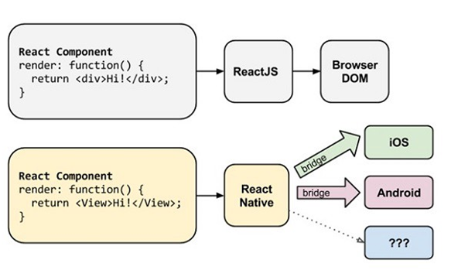

**Figure 3.0 React-Native Works**

**Source:** <https://medium.com/@guntoroagun/belajar-react-native-untuk-pemula-9cc10bfed6a2>

**3.1.2 The React Native Build Process Architecture**

When you type "react-native run-android" at the command prompt / terminal what happens is:

-Local node server will be created to collect all reacting native code

-React Native will create a native iOS or android project specifically for installed smartphones and this project will have a "runtime environment" to be able to run all of the React Native codes that we store on the local server node.

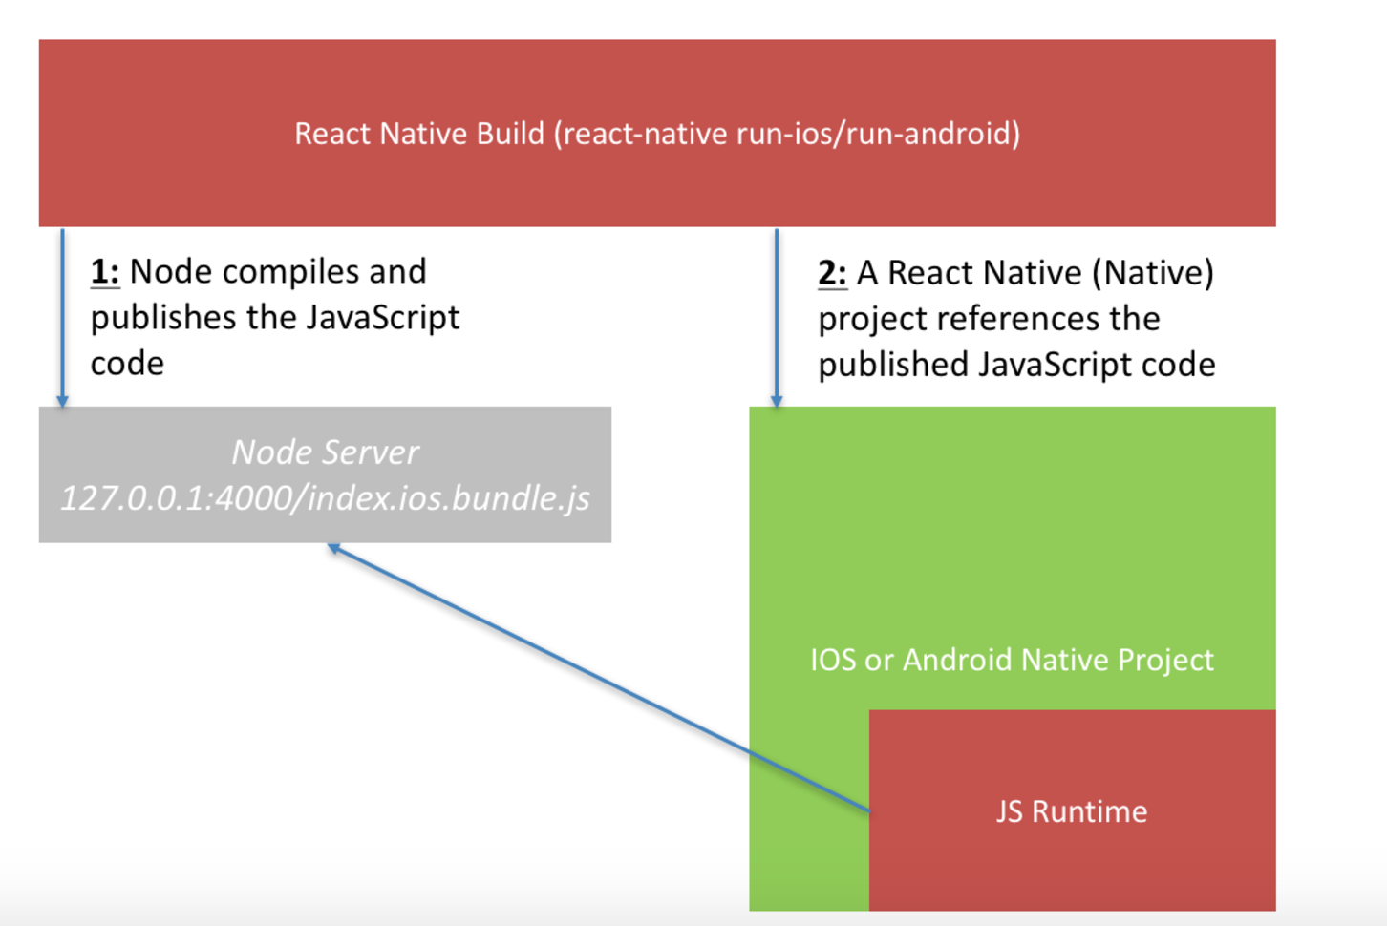

**Figure 3.1 Build Processes React-Native**

Source: [https://miro.medium.com/max/2904/1*ebiaNT0hXshqvpVKqkFkaA.png](https://miro.medium.com/max/2904/1*ebiaNT0hXshqvpVKqkFkaA.png)

1. **Implementation Apps of React-Native**

**A.Facebook & React Native**

React Native commenced as Facebook’s hackathon project developed in response to the company’s needs. Facebook wanted to bring all the advantages of web development – such as quick iterations and having a single team develop the whole product – to mobile. That is how React Native was brought to life and leveraged in mobile app development for both iOS and Android apps.

Why did they choose to React Native?

Originally, Facebook only developed to React Native to support iOS. However, with its recent support of the Android operating system, the library can now provide mobile UIs for both platforms. Facebook used React Native to develop its own Ads Manager app, creating both an iOS and an Android version. Both versions were created by the same team of developers.

Facebook also made React Native open-source, with the idea that compatibility with other platforms like Windows or tvOS could be operated on by the development community, so stay tuned.

**B.Instagram & React Native**

Instagram accepted the challenge to integrate React Native into their existing native app beginning from the simplest view you can imagine the Push Notification view which was basically implemented as the WebView. It did not require building navigation infrastructure, as UI was quite simple.

Why did they choose to React Native?

The dev team at Instagram faced a few problems on the way, but they substantially improved developer velocity. 85% to 99% of code was shared between Android and iOS apps, depending on products, thus the team was able to deliver the app much faster than they would have with a native solution.

**C.SoundCloud Pulse & React Native**

SoundCloud Pulse is an application for creators that helps them manage their accounts and keep their community humming. When the company started designing the second set of native apps, they faced a few obstacles. iOS developers were impossible to find and they didn’t want to have a huge gap between the iOS and Android releases. Therefore, an independent research team started to run user-testing sessions with React Native apps prototypes

**3.3 The Advantages and Disadvantages of React-Native**

**3.3.1 The Advantages:**

**A. One For All**

1 code for iOS and Android ?? Yes thats true .. With React Native, you only have to do the code once which code will later be bridged to Android (Java), and iOS

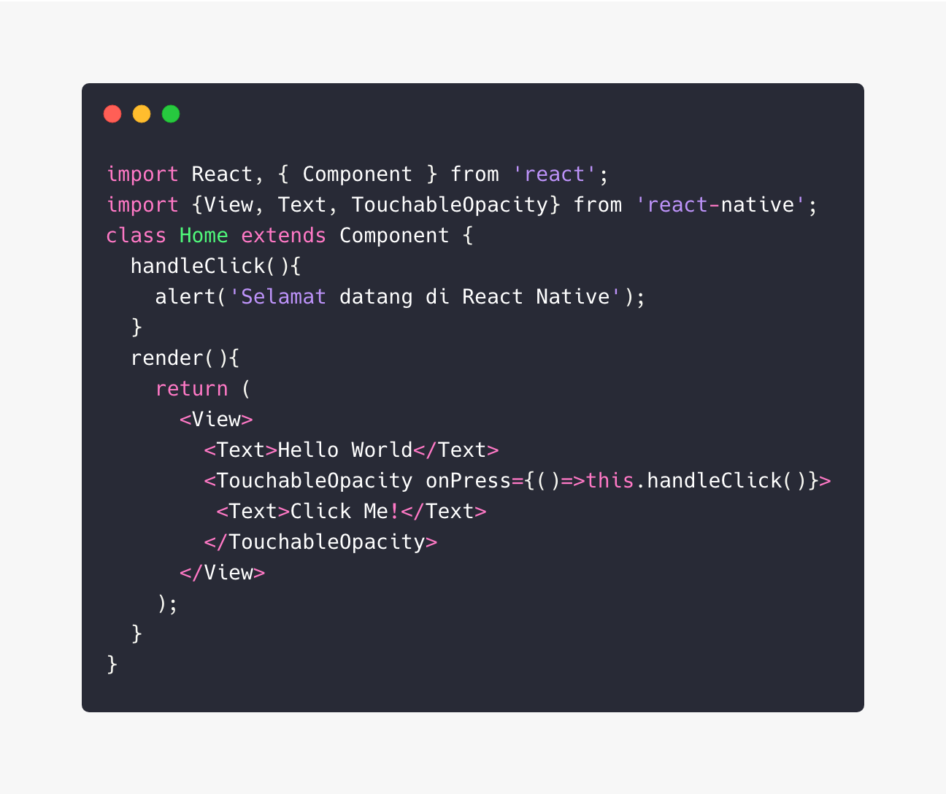**B. Simple Code**

**Figure 3.2 The example Code**

Each part that will be displayed on the screen is divided into Components, one example of the Component is "Home" like the example above. Then the rendering method is used to display data to the screen. "<View>" is used to replace "<div>" in HTML, why not just use a div? The answer is that View is a native component of Android and iOS bridged by javacript. Likewise with "<Text>" which is a replacement for "<p>". While "<TouchableOpacity>" can be used as a Button to perform actions like "onPress", which in the above code is tasked to call the "handleClick" method to call "alerts".

**C. Suitable for Startup**

Why do I dare say that React Native is suitable for startups? React Native is built with Javascript, so there's no need to bother paying for or looking for several programmers with different skillsets for Android or iOS. So it will save your startup COST for sure.

**3.3.2 Disadvantages:**

**A.** **Javascript!**

This may be a personal opinion, but especially the JavaScript ecosystem is not healthy enough for long-term development. React Native itself is very often updated, sometimes even too fast like from version 0.54 to 0.55 because there are bugs in the metro bundler version 0.54 once a month there is a framework update is certainly not fun for developers

**B. It's hard to make complex layouts and animations**

Creating animations such as shared transition elements or hero element transitions is not possible without dirty hacks on the component based systems react natively. where each screen is a separate component. and the Child Components of each Top View / Screen are not shareable.

**C. Longer debugging.**

Developers bring up one more problem with React Native technology — software debugging. It is much harder when using RN. It comes down to faster development but longer problem-solving which results in less accurate cost estimation

**CHAPTER IV**

**CONCLUSION AND SUGGESTION**

1. Conclusion

React is a framework for building applications using JavaScript. React Native is an entire platform allowing you to build native, cross-platform mobile apps, and React.js is a JavaScript library you use for constructing a high performing UI layer. React.js is the heart of React Native, and it embodies all React’s principles and syntax, so the learning curve is easy. The platform is what gave rise to their technical differences. Like the browser code in React is rendered through Virtual DOM while React Native uses Native API’s to render components on mobile. React uses HTML and with React Native, you need to familiarize yourself with React Native syntax. React Native doesn’t use CSS either. This means you’ll have to use the animated API which comes with React Native to animate different components of your application.Bottom line, React is ideal for building dynamic, high performing, responsive UI for your web interfaces, while React Native is meant to give your mobile apps a truly native feel.

1. Suggestion

We suggest even more fix debugging inconvenient bugs and issues people that we have been running into every day, but unfortunately, we haven't made as much progress on this as we would like. We recognize that debugging with React Native isn't great and we'll prioritize improving this in the future.

# Bibliography

**Agun,Guntoro.**2018. <https://medium.com/@guntoroagun/belajar-react-native-untuk-pemula-9cc10bfed6a2> [09/09/2019]

**Anputra,William**.2017. <https://medium.com/under10/react-native-cara-kerjanya-gimana-sih-8e4ab3542cff> [10/09/2019]

**Evkoski,Blagoja**.2017. <https://medium.com/we-talk-it/react-native-what-it-is-and-how-it-works-e2182d008f5e> [10/09/2019]

**Trnka,Dino**.2018. <https://medium.com/mop-developers/mobile-app-development-react-native-vs-native-ios-android-49c5c168045b> [11/09/2019]

**RadietyWachid,Ega**.2017 <https://medium.com/@radiegtya/mengapa-react-native-solusi-tepat-untuk-membuat-aplikasi-mobile-e43c30d824c> [11/09/2019]

**Johnston,Jia**.2017 <https://makeitopen.com/docs/en/1-3-data.html> [12/09/2019]

<https://facebook.github.io/react-native/> [12/09/2019]

<https://react-native.org/> [13/09/2019]